# Simple University Management System

* **Entities:**Student, Course, Professor, Department, Enrollment.
* **Relationships:** Student 'enrolls in' Course, Course 'taught by' Professor, Professor 'works in' Department.

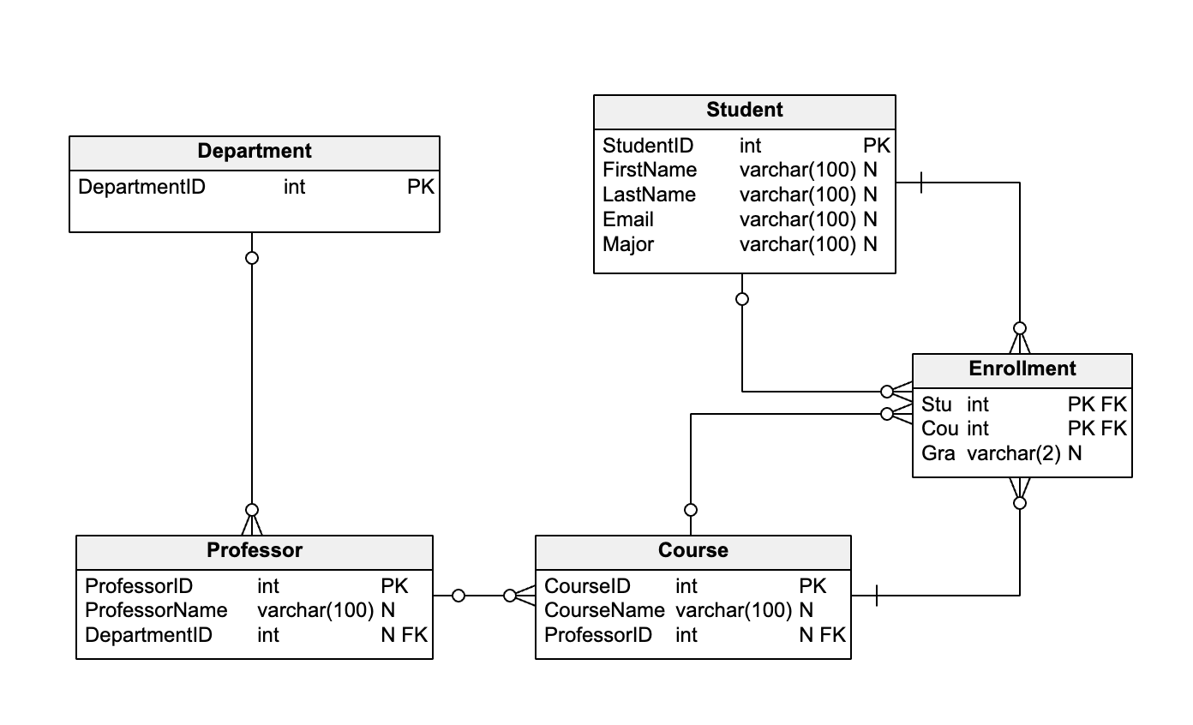

In this schema:

* The Student table represents the students who enroll in courses.
* The Department table represents the departments in which professors work.
* The Professor table represents the professors who teach courses. Each professor works in a department, which is represented by the foreign key DepartmentID.
* The Course table represents the courses in which students enroll. Each course is taught by a professor, who is represented by the foreign key ProfessorID.
* The Enrollment table represents the many-to-many relationship between students and courses. Each row in this table represents a student enrolled in a course and the grade they received in that course.

Questions :

Create a simple console app using efcore and any sql db, create relevant relationships and do CRUD OPERATIONS.